

Sales Tips Guide for White-Label Reputation Resellers

Welcome to the Sales Tips Guide designed specifically for Review Dingo's resellers. This guide provides helpful tips and advice on successfully selling our reputation management software. Use these strategies to enhance your sales approach and achieve outstanding results.

Objection Handling Scripts
Being prepared to address questions and concerns is crucial for closing deals with confidence. Here's a guide on handling common objections:

Price Concerns:
- Script: "I understand that cost is a concern. Let’s look at the potential return on investment you’ll gain through improved online presence and increased customer trust. Our solution is designed to drive business growth and pays for itself over time."
- Tip: Highlight any flexible pricing plans or bundled services that can provide more value to the client.

Skepticism About Effectiveness:
- Script: "I get it; you want proof that it works. I can share some success stories from businesses similar to yours that have seen significant improvements in both reputation and sales after implementing our software."
- Tip: Always have data or case studies ready to illustrate the software's benefits.

Time to Implement:
- Script: "Our platform is very user-friendly and requires minimal setup time. Plus, we offer comprehensive support during the onboarding process to ensure everything runs smoothly."
- Tip: Emphasize the streamlined integration process and round-the-clock customer support.

Discovery Call Framework
A well-structured discovery call is essential to uncover your client's needs and showcase how your solution can address them.



Introduction:
- Start by building rapport and explaining the call's agenda. "Thanks for taking the time today. I’d love to learn more about your business and discuss how we can help enhance your online reputation."

Needs Analysis:
- Use open-ended questions to draw out client needs: "Can you tell me about your current challenges with online reviews?" or "What goals are you aiming to achieve with your online presence?"

Value Proposition:
- Align their needs with your solution. "Based on what you've shared, our platform can streamline your review management and boost your online rankings, helping you attract more customers."

Next Steps:
- Establish clear follow-up actions. "I'd love to schedule a demo to show you exactly how our software works in action. When are you available?"

Expert Sales Strategies
Elevate your sales approach with these expert strategies that focus on client-centric selling and long-term relationships.

Solution Selling:
- Shift your focus from selling features to selling solutions. Connect how specific capabilities of the software solve pain points and deliver value.

Leverage Testimonials:
- Use existing client testimonials to build trust and credibility. "Our clients have seen exceptional improvements in customer engagement and loyalty. Would you like to hear their stories?"

Build Relationships:
- Develop trust by genuinely understanding client needs and providing consistent support, maintaining a long-term perspective beyond just the sale.

Quick Sales Tips
For swift sales wins, keep these quick tips in mind to accelerate your sales cycle:

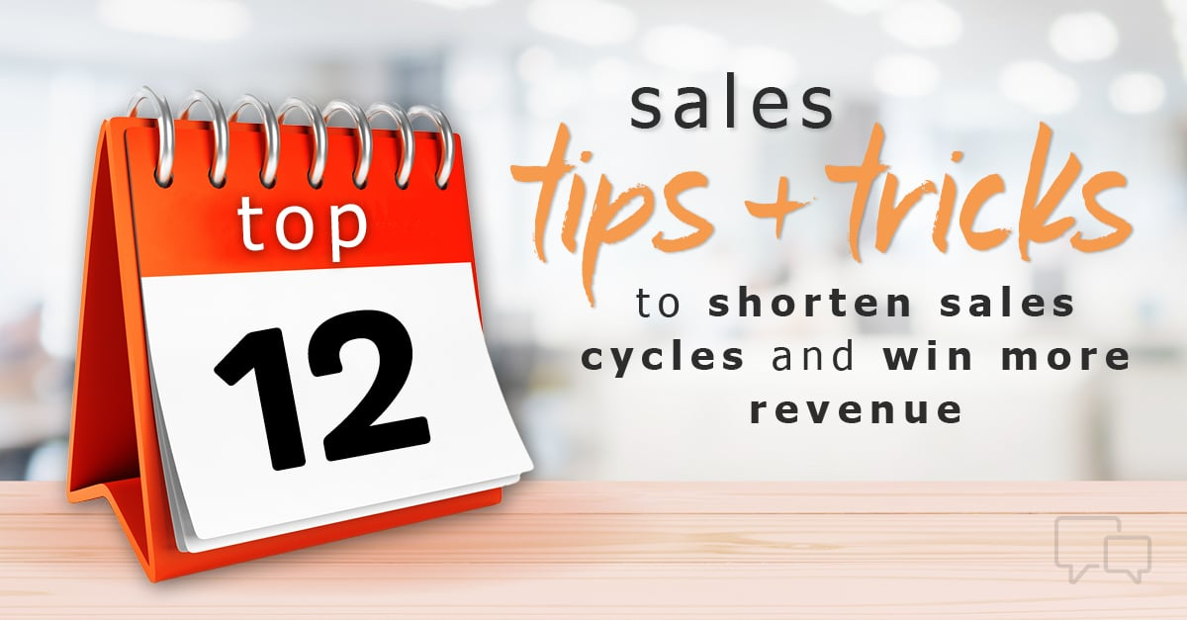

Highlight Unique Features:
- Quickly point out what sets your software apart from competitors, whether it's ease of use, comprehensive support, or advanced functionalities.

Use Live Demos:
- Don't just tell, show. Offering immediate, live demos allows prospects to see the value first-hand and creates a sense of urgency.

Be Personable and Relatable:
- Personalize interactions to make clients feel valued, tailoring your conversations based on their specific business context.

With these sales tips at your disposal, you'll be better equipped to engage clients effectively, overcome objections, and close deals consistently. Good luck, and happy selling!

Sales Tips from Top Resellers

Jumpstarting your sales strategy in online reputation management might seem challenging, but don't worry— we've got you covered. Check out these five sales tips from our top resellers to help you get started selling our software like a pro. Let’s dive in and make those sales happen!

Sales Tip #1
Fact find on the original call. Ask leading questions to have the client open up about their online reviews or lack of online reviews. Find the pain points!
- "Do you currently generate feedback from your customers about your service?"
- "How do you manage your online reviews?"
- "Would you see a benefit of aggregating all of your reviews from various websites into one page on your website?"
- "Would it improve your business if you were able to get feedback privately from customers before they leave an online review?"

Sales Tip #2
Lead with the review product on cold calls.
- "Hi, I noticed that you currently have a 2-star rating on Google. Does this accurately represent your business?"
- "Hi, I see that you have 25 reviews on HomeAdvisor, 20 on GMB, and 10 on FB. How cool would it be to have this all aggregated on one page of your website?"
- "Do you see the benefit of having your website constantly being updated with your online reviews?"

Sales Tip #3
Show live examples of current clients in original emails or calls to prospects.
- You need to create a portfolio of existing clients to demo the product. Customers want to see live examples. Even if you have to discount in the beginning to generate the portfolio - do it!
- We are sending links to 4 to 5 live client testimonial pages each call.
- We constantly show our clients that have 1st party ratings showing the stars on Google Organic via the review widget as an example of how we can improve their online presence.

Sales Tip #4
Schedule a demo.
- Once a client sees the portal the sale is a done deal.
- We use GoToMeeting to provide a demo of how the software works, show them the widget, how to send client emails, etc.
- Before the Demo, always upload the client logo and send them a live feedback request email with their branding while on the live call. This hits home and they love seeing their company look so professional.

Sales Tip #5
Tier your pricing and offer free trials.
We offer free trials and no long-term commitments. Clients need to see results from the software before committing. Offer tiered pricing with add-ons tailored to your client’s needs.
- $200/mo A fully managed review service, including customer information input.
- $250/mo A fully managed review and listing management service.
- $300/mo A fully managed review, listing management, and Webchat service.

There you have it—five easy tips to kick your sales into high gear. Remember, it’s all about understanding your client’s needs, showcasing real results, and offering flexible options. So, get out there, charm those clients, and watch your sales soar! Happy selling!

